**My Story: Step by Step process of How I Can Learn Machine Learning**

**Just For Read:**

Hola a todos (Hello Everyone in Spanish 😊), My Name is Nivitus. This is my 6th blog posted on medium. In this Blog I am going to explain the way of how I learn the machine learning in 3-4 months comprehensively. So let’s get ready to dive into the journey of ML.

It took me three to four months to leave that life behind and start feeling like I belonged to the exclusive world of people who can tell their medians from their means, their x-bars from the neighborhood pub, and who know how to teach machines what they need to learn.

The transformation process was not easy and demanded hard work, lots of time, dedication and required plenty of help along the way. It also involved well over hundreds of hours of “studying” in different forms and an equal amount of time practicing and applying all that was being learnt. Whatever happened during my learning path I wasn’t stop my learning stuffs always keep to try push yourself to edge of your goal point.

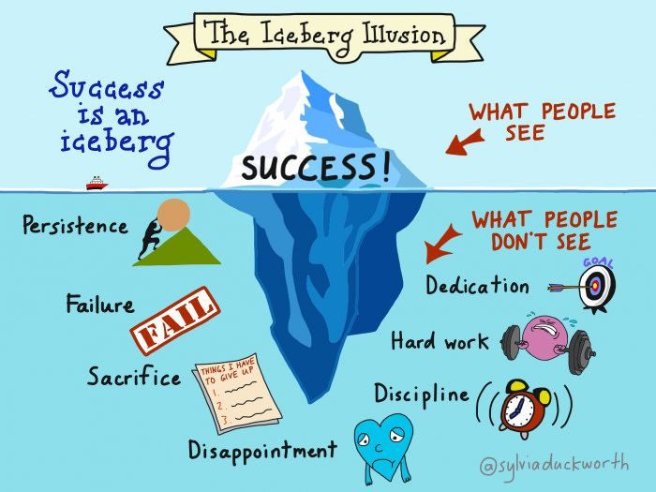

The point of this article is to help you if you are looking to make a similar transformation but do not know where to start and how to proceed from one step to the next. If you are interested in finding out, read on to get an idea about the topics you need to cover and also develop an understanding of the level of expertise you need to build at each stage of the learning process.

## **Understand the basics**

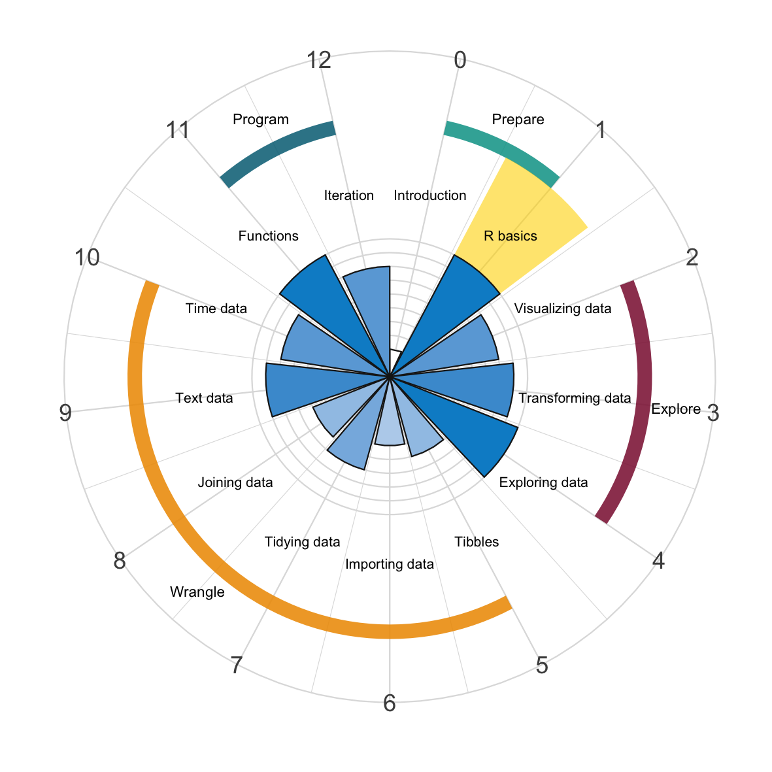

**All of the Basics you need to get before start your Journey.**

Spend a couple of days enhancing your “general knowledge” about the field of data science and machine learning. You may already have ideas and some sort of understanding about what the field is, but if you want to become an expert, you need to understand the finer details to a point where you can explain it in simple terms to just about anyone.

**I Suggested topics:**

* What is Data Science?
* What is Machine Learning?
* What is Artificial Intelligence?
* What is Big Data?
* What is Deep Learning?
* What is Data Analytics?
* How are the above domains different from each other and related to each other?
* How are all of the above domains being applied in the real world?

Note: Here I’ll mentioned my mentor and some of the YouTube channels which are really helpful to when I start to learn Machine Learning and all of those stuffs.

Krish Naik: <https://www.youtube.com/user/krishnaik06>

Corey Schafer: <https://www.youtube.com/user/schafer5>

iNeuron: <https://www.youtube.com/channel/UCb1GdqUqArXMQ3RS86lqqOw>

I think these two channels are enough to learning all those machine learning and Machine Learning Basics.

## **Learn some Statistics**

I have a confession to make. Even though I feel like a machine learning expert, I do not feel that I have any level of expertise in statistics. Which should be good news for people who struggle with concepts in statistics as much as I do, as it proves that you can be a data scientist without being a statistician.

* Mean, Median, Mode and Variance
* Gaussian Distribution
* Standard Normal Distribution
* Probability Density Function
* Cumulative Distribution Function
* Skewness
* Log Normal Distribution
* Percentiles
* Central Limit Theorem

Note: Here I’ll mentioned Enough Statistics concepts once you’ll finished of those things you got the much more clear idea about the statistics behind the data science and Machine learning.

Krish Naik: <https://www.youtube.com/user/krishnaik06>

StatQuest: <https://www.youtube.com/user/joshstarmer>

iNeuron: <https://www.youtube.com/channel/UCb1GdqUqArXMQ3RS86lqqOw>

## **Learn some Mathematics**

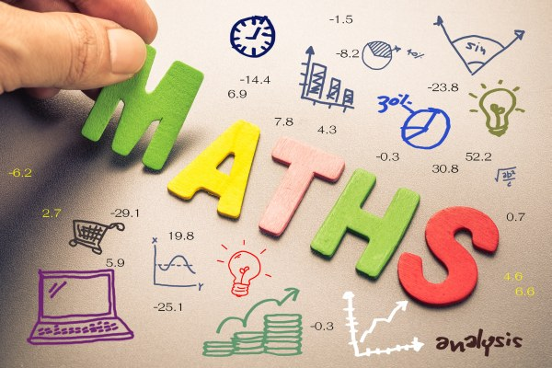

When you Google for the math requirements for data science, the three topics that consistently come up are calculus, linear algebra, and statistics. The good news is that — for most data science positions — the only kind of math you need to become intimately familiar with is statistics. You need not study all of the three concepts just take basics of three and knowing how to apply the concepts into the Programming for solving the real world use cases.

* Linear Algebra
* Calculus
* **Probability and statistics**

Here I divided into the math in more comprehensive way. You can learn step by step these topics

* Maths – Machine Learning
* Maths – Deep Leaning
* Maths in Algorithms and Geometric Intuition
* Indepth understanding Maths in ML and DL

Krish Naik: <https://www.youtube.com/user/krishnaik06>

StatQuest: <https://www.youtube.com/user/joshstarmer>

iNeuron: <https://www.youtube.com/channel/UCb1GdqUqArXMQ3RS86lqqOw>

## **Learn Python**

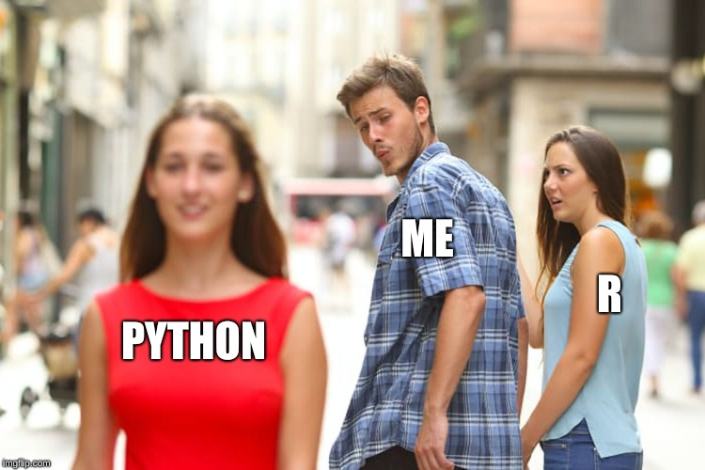

Programming turned out to be easier to learn, more fun and more rewarding in terms of the things it made possible, than I had ever imagined. While mastering a programming language could be an eternal quest, at this stage, you need to get familiar with the process of learning a language and that is not too difficult. 😊😊😊

I’m Only Learned Python maybe I have an idea about learning R in the Future. You can learn both Python and R are very popular and mastering one can make it quite easy to learn the other.

Here I suggested some of the Python topics you need to understand those thing before you dive deep into to the data science and Machine Learning.

* Variables
* Operators
* Data Types
* Functions
* Control Statements
* Control Structures
* Exception Handling
* OOPs

Krish Naik: <https://www.youtube.com/user/krishnaik06>

Corey Schafer: <https://www.youtube.com/user/schafer5>

Code Basics: <https://www.youtube.com/channel/UCh9nVJoWXmFb7sLApWGcLPQ>

iNeuron: <https://www.youtube.com/channel/UCb1GdqUqArXMQ3RS86lqqOw>

**Libraries That’s Matters!**

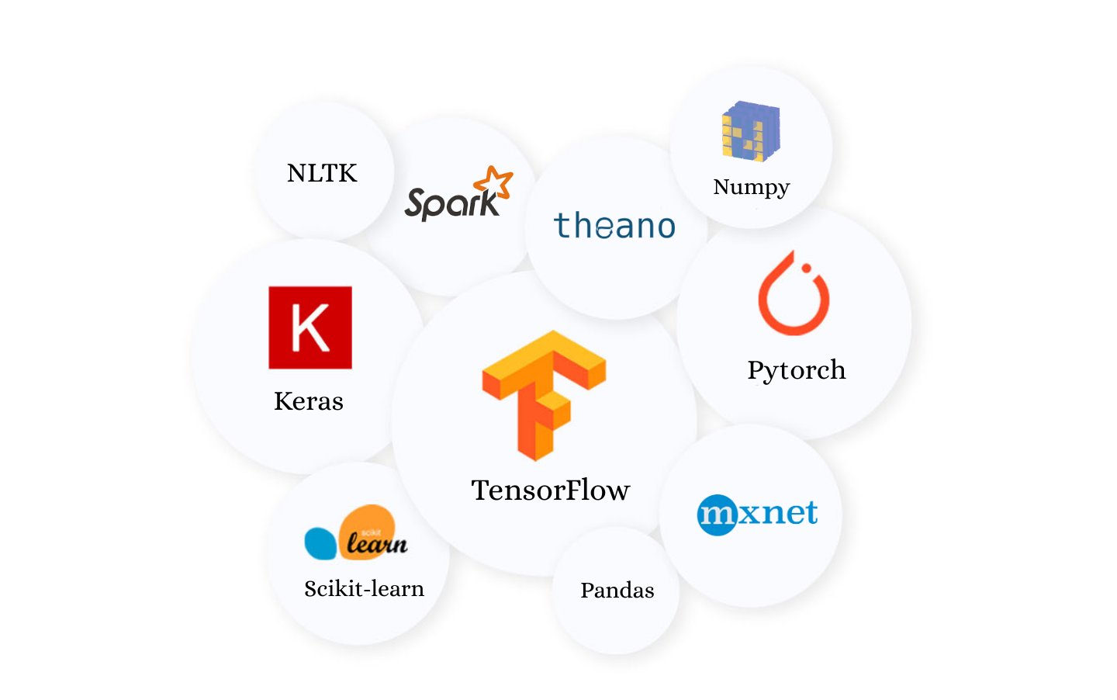

**Enough to Deeper In Data Science**

After getting all of the python basics you need to concentrate your python library skills which is easy to make your work when you learn data science and machine learning and working some data science projects

Here I suggested some of the Important Python Libraries you need to understand those thing before you dive deep into to the data science and Machine Learning.

* Numpy
* Pandas
* Scipy
* Scikit-learn
* Seaborn
* Matplotlib

## **Complete an Exploratory Data Analysis**

Exploratory Data Analysis (EDA): Exploratory data analysis is a complement to inferential statistics, which tends to be fairly rigid with rules and formulas. At an advanced level, EDA involves looking at and describing the data set from different angles and then summarizing it.

Data Analysis: Data Analysis is the statistics and probability to figure out trends in the data set. It is used to show historical data by using some analytics tools. It helps in drilling down the information, to transform metrics, facts, and figures into initiatives for improvement.

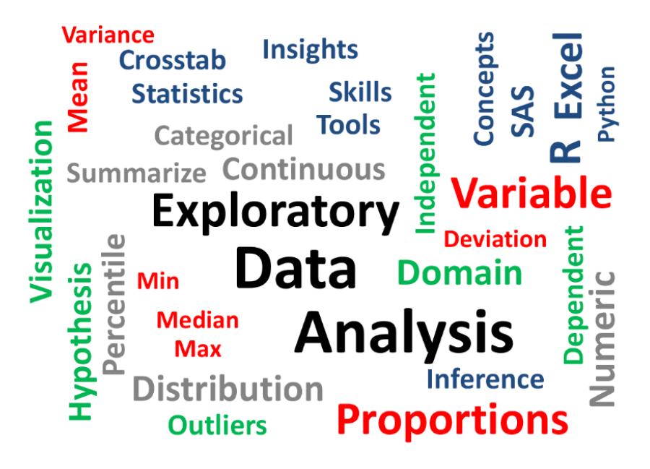

We will explore a Data set and perform the exploratory data analysis. The major topics to be covered are below:

* Handle Missing value
* Removing duplicates
* Outlier Treatment
* Normalizing and Scaling ( Numerical Variables)
* Encoding Categorical variables( Dummy Variables)
* Bivariate Analysis

Krish Naik: <https://www.youtube.com/user/krishnaik06>

iNeuron: <https://www.youtube.com/channel/UCb1GdqUqArXMQ3RS86lqqOw>

## **Create supervised & unsupervised Models**

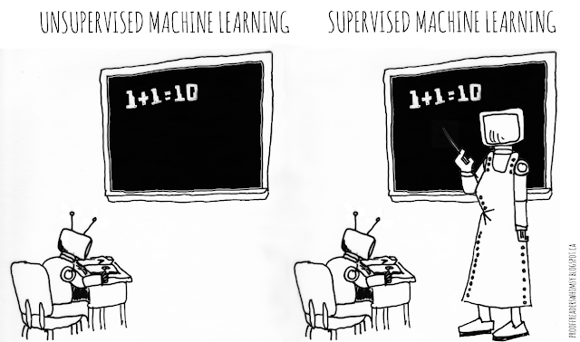

**Topics to cover:**

**supervised**

* Logistic regression
* Classification trees
* Ensemble models like Bagging and Random Forest
* Supervised Vector Machines

You have not really started with creating models till you have done this:

* Take a dataset, create models using all the algorithms you have learnt. Train, test and tune each model to improve performance. Compare them to identify which is the best model and document why you think it is so

**unsupervised**

That is where unsupervised machine learning algorithms come in. This is not the time to bore you with details about what these are all about, but the good news is that once you reach this stage, you have moved on into the world of machine learning and are already in elite company.

Topics to cover:

* Clustering
* Association rules

Milestone exercise:

* Practice K-means clustering on 3 different datasets from different industries or interest areas

Krish Naik: <https://www.youtube.com/user/krishnaik06>

iNeuron: <https://www.youtube.com/channel/UCb1GdqUqArXMQ3RS86lqqOw>

## **Take your own Data Science and ML Projects**

By now you are almost ready to unleash yourself to the world as a machine learning pro, but you need to showcase all that you have learnt before anyone else will be willing to agree with you.

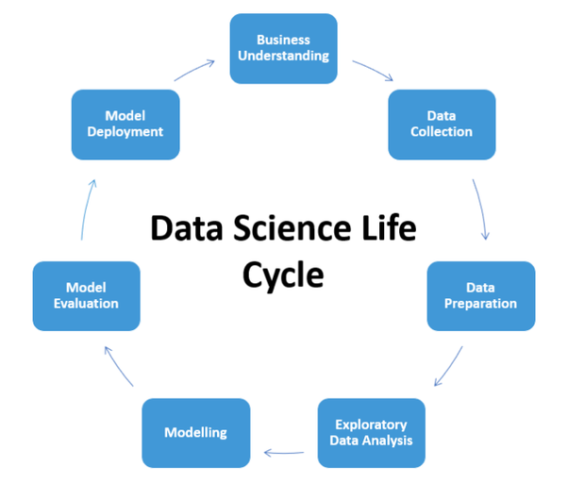

The internet presents glorious opportunities to find such projects. If you have been diligent about the previous eight steps, chances are that you would already know how to find a project that will excite you, be useful to someone, as well as help demonstrate your knowledge and skills.

Topics to cover:

* Data collection, quality check, cleaning and preparation
* Exploratory data analysis
* Model creation and selection
* Project report
* Deploying.

Krish Naik: <https://www.youtube.com/user/krishnaik06>

iNeuron: <https://www.youtube.com/channel/UCb1GdqUqArXMQ3RS86lqqOw>

**Best Wishes:**

Machine learning and artificial intelligence is a set of skills for the present and future. It is also a field where learning will never cease and very often you may have to keep running to stay in the same place, as far as being equipped with the most in-demand skills is concerned.

However, if you start the journey well, you will be able to understand how to go about taking the next step in your learning path. As you must have gathered by now, starting the journey well is a pretty challenging exercise in itself. If you choose to start upon it, I hope this article will have been of some help to you and I wish you the very best.

I Hope all of You Like this blog. If you wanna say more about in this blog just contact me.

**Name: Nivitus**

**Mobile Number: 9994268967**

**Email: nivitusfdo007@gmail.com**

You can Ping me on these

